**NAME: Sharvayu Zade**

**PRN: 23070521135**

**Sec: B**

**Batch: B2**

**Course: DBMS Lab**

**1. CREATE TABLE**

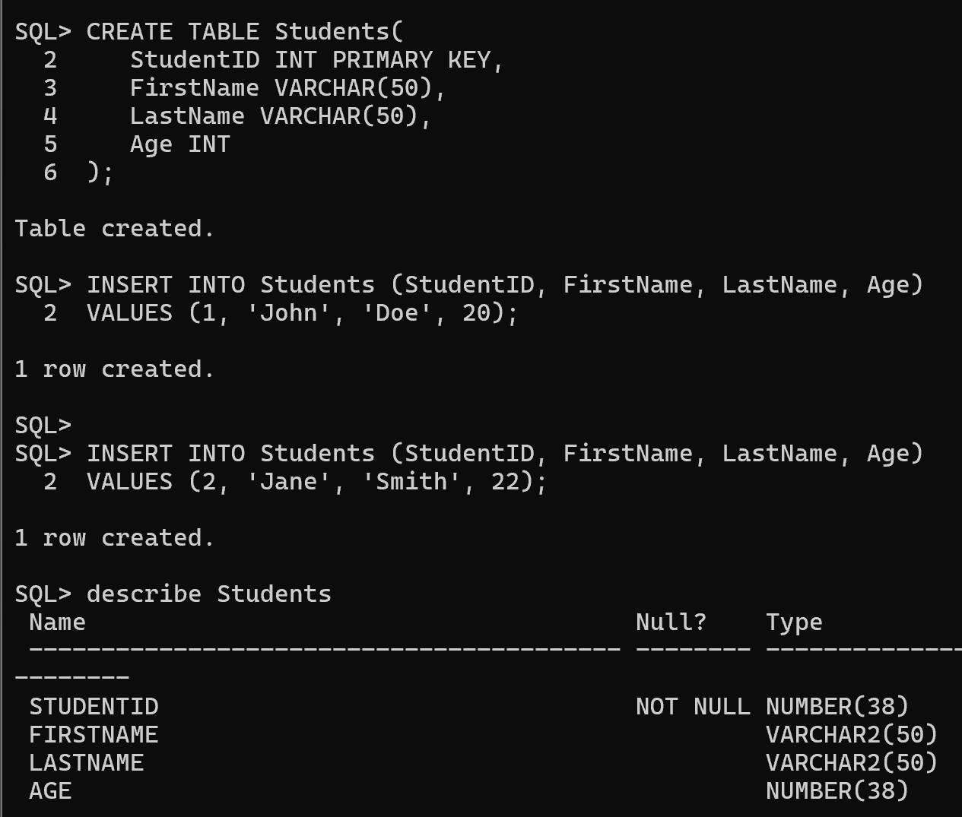

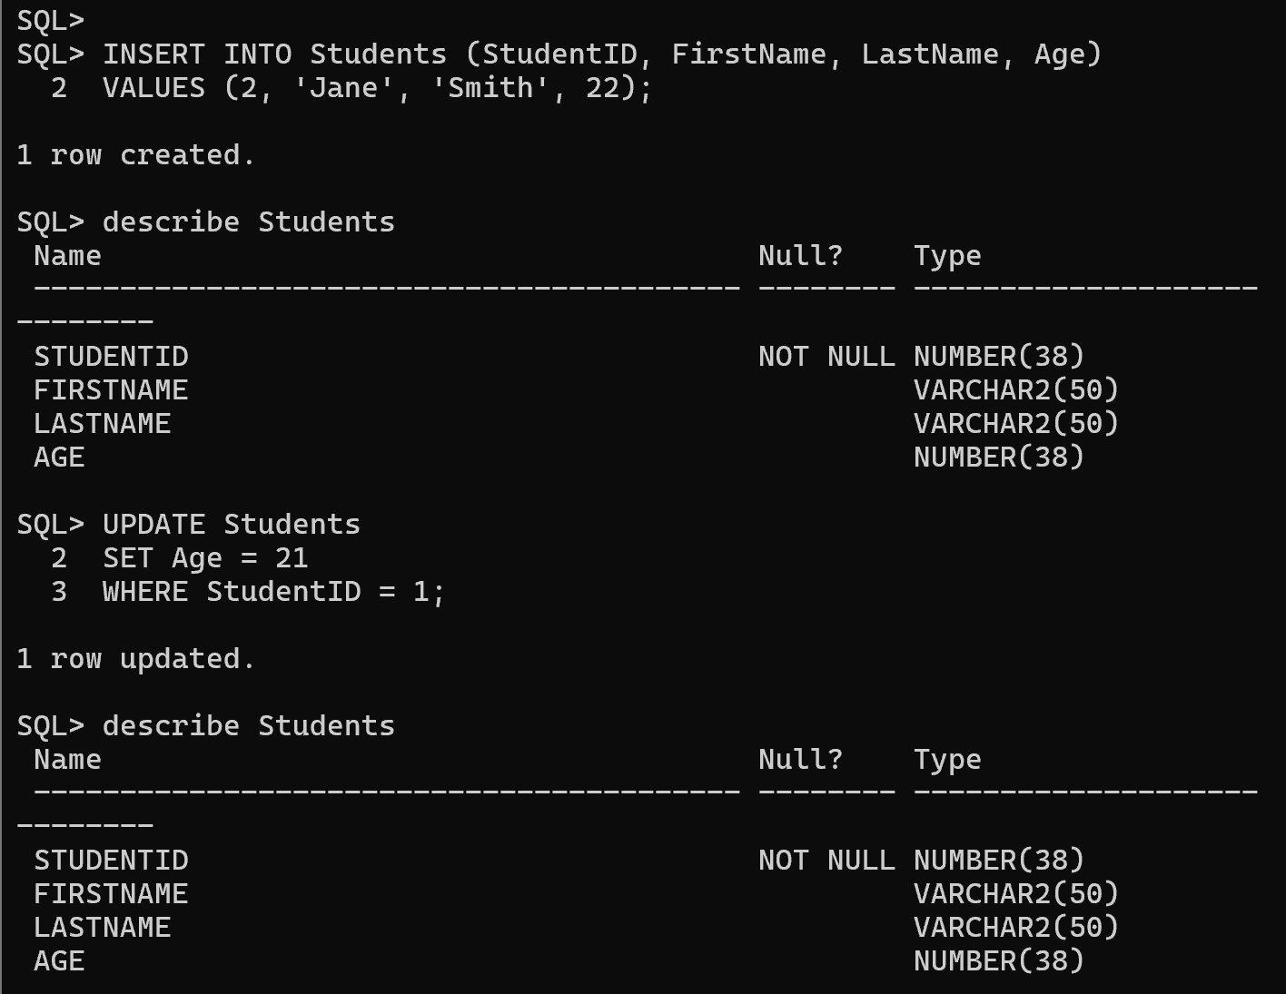**2. INSERT**

**3. Delete**

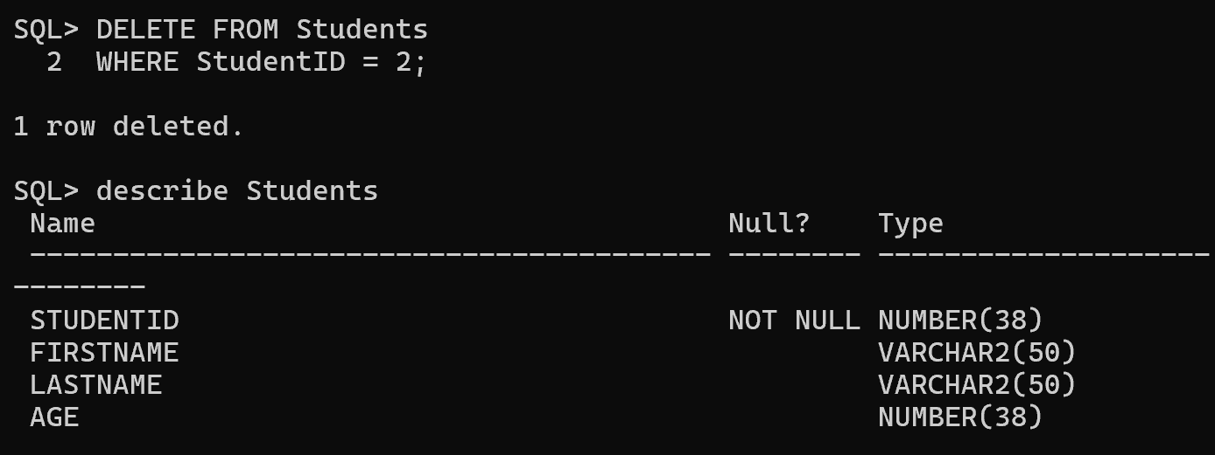

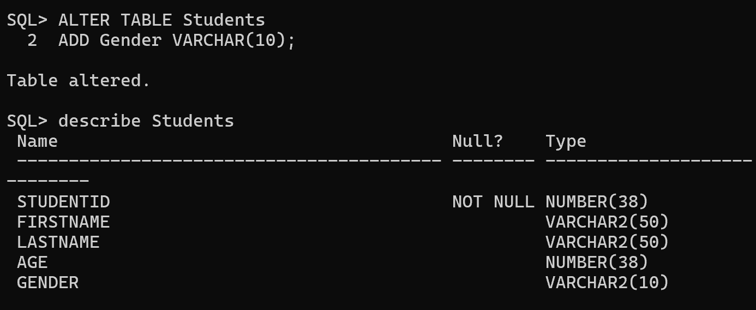**4. Alter Table**

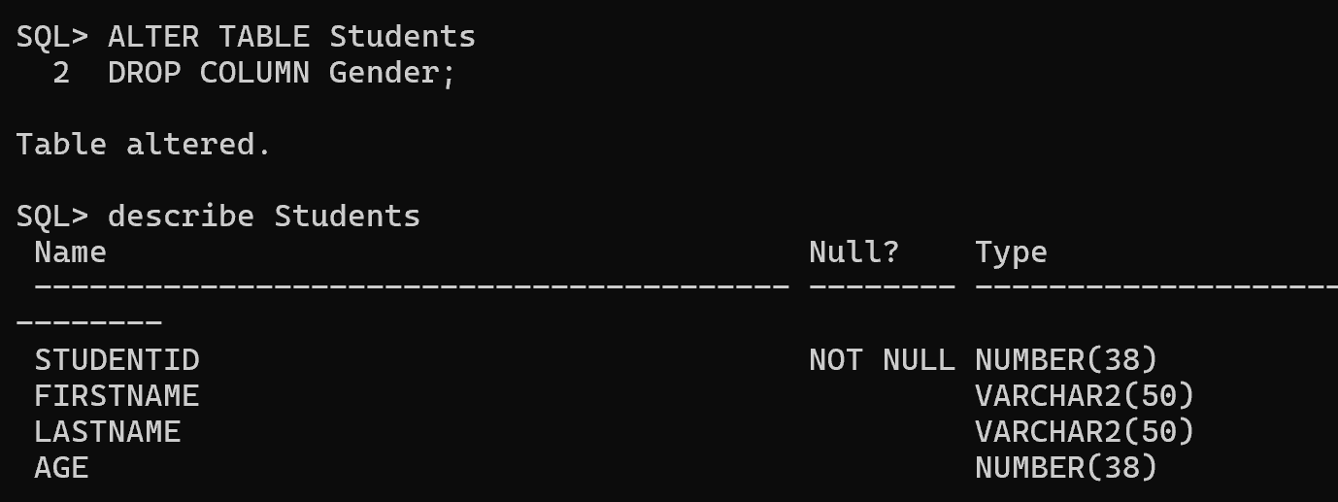**5. Alter Drop Column**

**6. PRIMARY KEY**

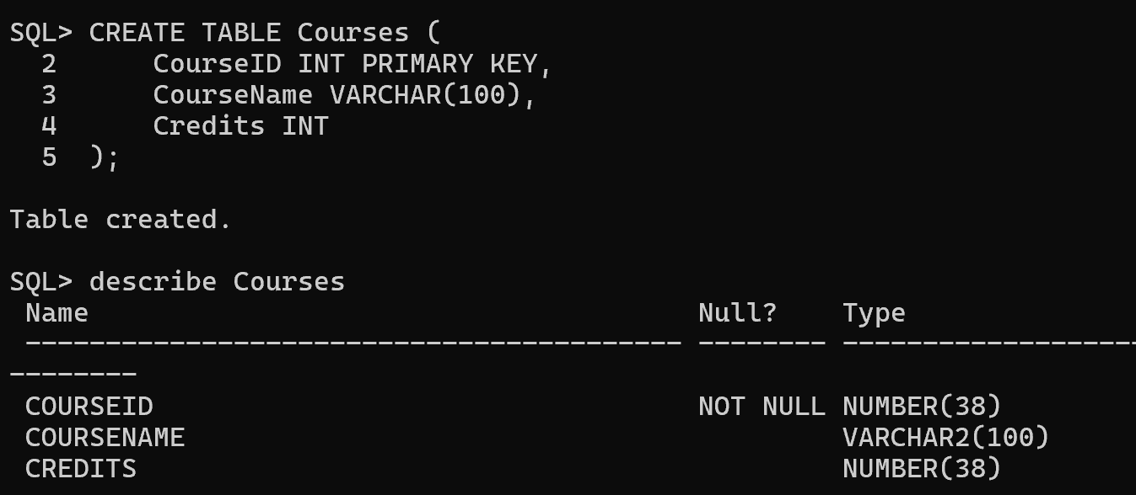

**7. UNIQUE KEY**

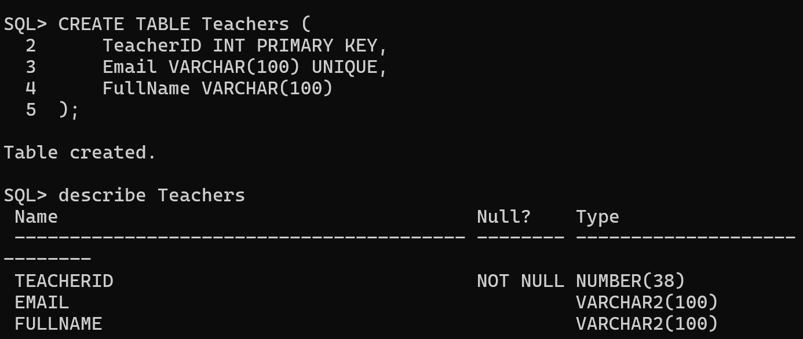

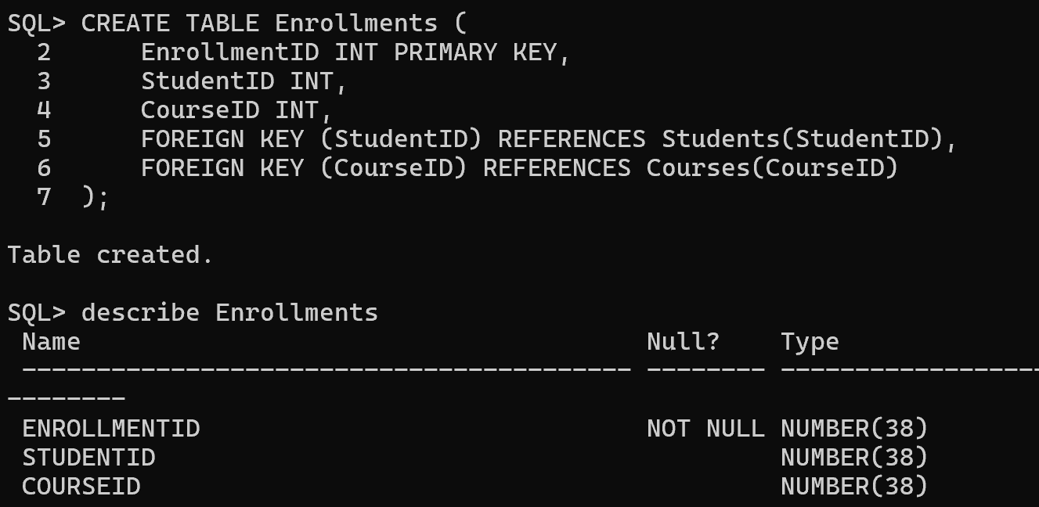**8. FOREIGN KEY**

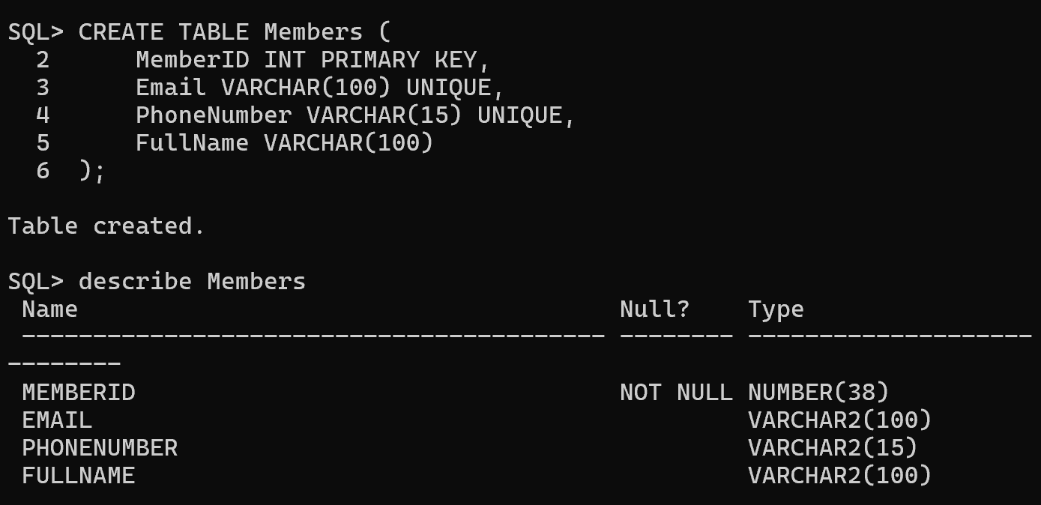**9. CANDIDATE KEY**

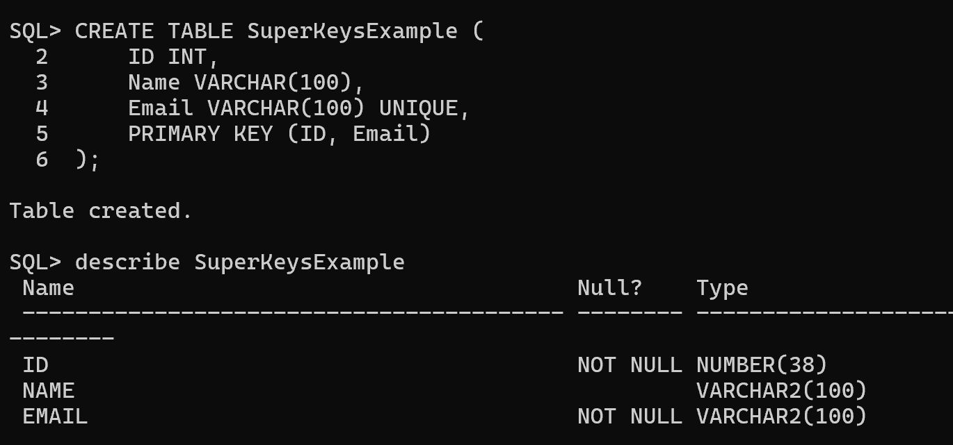**10. SUPER KEY**

**11. ALTERNATE KEY**

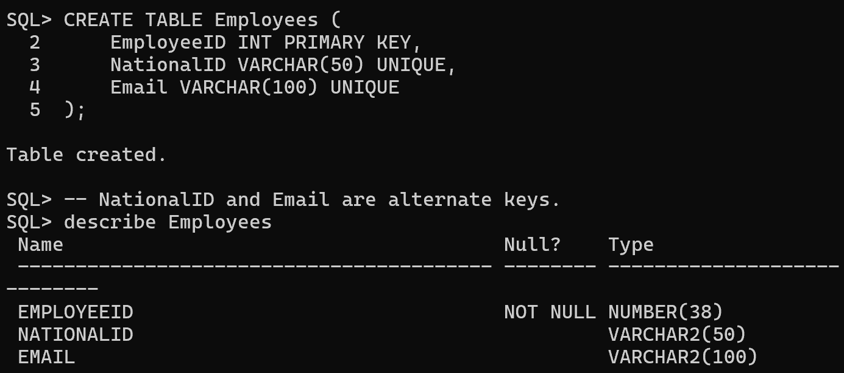

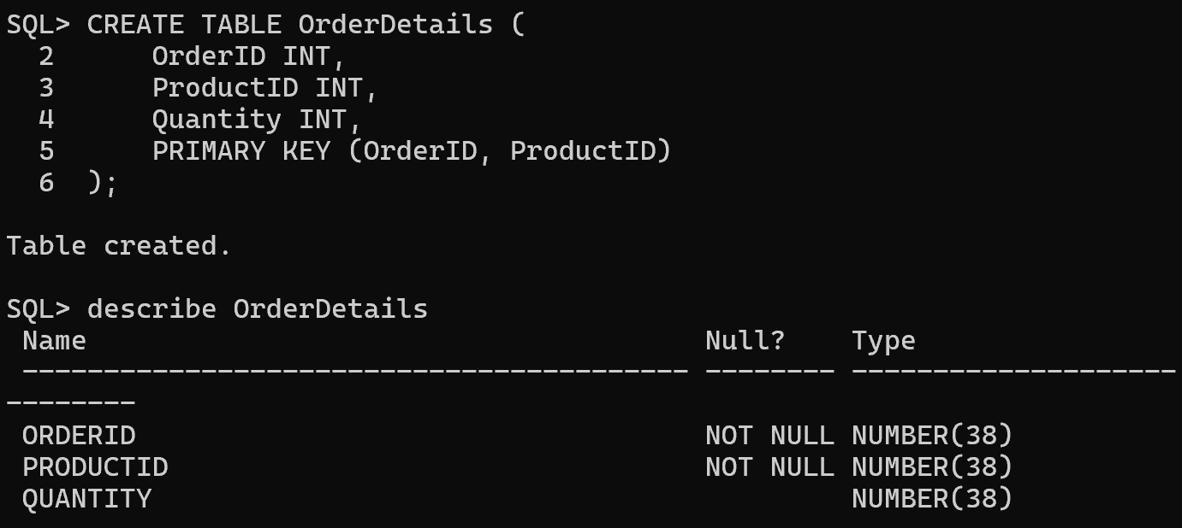**12. COMPOSITE KEY**

**Practice steps**

1. **Create each table and verify using DESC <table_name>;.**
2. **Insert 5 rows to test constraints like primary key, unique, and foreign key.**
3. **Use SELECT queries to confirm the data integrity.**
4. **Experiment by violating constraints to understand their impact**

